Bold new work ready to Emerge from free showcase
By Elaine O'Connor
18 July 2012

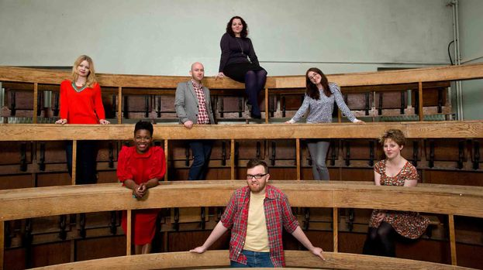
Pete Dibdin

An intimate event will give Glasgow theatre fans a chance to see and talk about new work being made in Scotland.

The evening of spoken word, conversation and performance at The CCA on Friday, July 22 will introduce the audience to the seven participants in this year’s National Theatre of Scotland Emerge programme.

The Bank of Scotland sponsored project annually supports emerging talents, giving them an opportunity to develop their work.

This year Eilidh Daniels, Adura Onashile, Catriona Lexy Campbell, Martin O’Connor, Deborah Hannan, Rob Jones and Sarah Macdonald.

On Friday evening, they’ll each show or talk about some of the work they’re currently involved in; everything from performances about showbiz in Gaelic, to tales of notorious murderers.

Martin O’Connor’s work, Theology is a set of spoken word pieces which celebrate the great Glasgow patter.

He said: “There’s something very poetic about the way we speak in Glasgow, the way we use language and what we do with words is incredibly creative.

“But we’re often told not to celebrate that but to ‘speak properly’; I don’t agree with that.”

For Theology, Martin has created different pieces such as Glory Be, a Glasgow interpretation of the Catholic order of mass – for example, from the Prayers for the Faithful:

“We pray for aw thame that are sick, and needy, and on the waiting list for hospital appointments – and see cause it takes that long to get there, aw roon the hooses, we pray that the 34 turns up on time fur them.”

A Govan of the Mind was inspired by Lawrence Ferlinghetti’s A Coney Island of the Mind; and takes bits and pieces from real life in Glasgow.

“I took parts from what we hear all around us every day,” said Martin. “Things that I’ve overheard, phrases that I remember from school, or that I hear on the bus.

“I did a takeover at the Arches restaurant last year, where I blew up huge words to hang on the wall, good Glasgow words like ‘hingmy’, and got people to tell me their own favourites.”

For Martin, Emerge will be an opportunity to work alongside other artists to develop these ideas further in the next year, working with director Rob Jones.

“We met up for the first time to do a photoshoot,” he said, “So I didn’t know the others before that, but it will be really interesting to see what everyone wants to do.
“I’m quite specific about what I want to use the time for; the real benefit for me will be the chance to work with other people with different types of expertise or approach.

“Quite often, I work on my own, so it will be a change to have other people to talk about ideas with and ways to make this work into something more.”

Vicky Featherstone, artistic director, National Theatre of Scotland added: “The National Theatre of Scotland’s success over the last six years has been built on the talent of Scottish artists who remain at the heart of our organisation.

“Bank of Scotland’s Emerge Programme at the National Theatre of Scotland is a vital organisational resource that helps us identify and nurture emerging and diversifying artists.

“We are committed to enabling a new generation of theatre-makers to become key players in Scotland’s successful cultural future.”

Emerge is at the CCA, Sauchiehall Street, from 6.30pm on Friday, July 20.

